REPORT AND ANALYSIS PLAN
TRANSACTION TIMES
Sue Blackburn
Brady Brown
Randy Christensen
Kilee Robinson

Math 2040

3/28/2013

Poster Project Report and Analysis Plan
“Transaction Times”
Research Question
“Does the time it takes to perform each transaction at the drive-up windows vary depending on the time of the day it is performed, such as the morning, afternoon, and evening?”
Data Collection Plan
Randy Christensen works at America First Credit Union and he will be the main source of our data collection. He works a variety of shifts and will be able to provide us with varying data about transaction times at the credit union drive-up windows. Our target population is all customers who use the drive-up windows at America First Credit Union at the Jordan Landing Branch Monday through Saturday. We will be collecting transaction times in seconds from the morning, afternoon and evening. We will choose at least 30 transactions/customers randomly from each time of the day from which to create our data sets.
To decide the approach to collecting our data we used a calculator to find a random number between 1 and 5. The random number given to us was 4. We will collect the data from every fourth car. Starting at the opening of business hours we will collect the data described above for every fourth car from 9:00 AM until 11:59 AM, which will also be referred to as “morning”. We will then collect data from every fourth car starting at 12:00 PM until 2:59 PM, which will also be referred to as “afternoon”, and then repeat for the hours of 3:00 PM until the close of business that day at 6:00 PM, which will also be referred to as “evening”. This will give us three different data sets to compare.

Data Collection Tables
 | Time of Day
Transaction Length  (in seconds) | Morning | Afternoon | Evening | Totals
0 - 29 | 0 | 0 | 0 | 0
30 - 59 | 3 | 2 | 2 | 7
60 - 89 | 7 | 12 | 6 | 25
90 - 119 | 12 | 7 | 10 | 29
120 - 149 | 4 | 4 | 3 | 11
150 - 179 | 2 | 3 | 2 | 7
180 - 209 | 0 | 1 | 1 | 2
210 - 239 | 3 | 3 | 2 | 8
240 - 269 | 2 | 0 | 0 | 2
270 - 299 | 1 | 0 | 1 | 2
300 - 329 | 0 | 0 | 0 | 0
330 - 359 | 0 | 1 | 0 | 1
360 - 389 | 0 | 1 | 0 | 1
390 - 419 | 0 | 0 | 2 | 2
420 - 449 | 0 | 0 | 0 | 0
450 - 479 | 0 | 1 | 0 | 1
480 and above | 0 | 0 | 1 | 1
Totals | 34 | 35 | 30 | 99
 | Time of Day
Transaction Type | Morning | Afternoon | Evening | Totals
Deposit | 25 | 26 | 20 | 71
Withdrawal | 1 | 5 | 6 | 12
Deposit with Cash Back | 5 | 3 | 1 | 9
Cashier's Check | 0 | 0 | 1 | 1
Other | 3 | 1 | 2 | 6
Totals | 34 | 35 | 30 | 99

Summary Statistics
Column | n | Mean | Variance | Std. Dev. | Std. Err. | Median | Range | Min | Max | Q1 | Q3 | IQR | Sum
Morning | 34 | 122.52941 | 3872.9233 | 62.232815 | 10.67284 | 104 | 221 | 49 | 270 | 83 | 127 | 44 | 4166
Afternoon | 35 | 140.68571 | 9086.045 | 95.32075 | 16.112148 | 106 | 405 | 49 | 454 | 85 | 164 | 79 | 4924
Evening | 30 | 158.2 | 17485.477 | 132.23265 | 24.14227 | 110 | 630 | 45 | 675 | 89 | 168 | 79 | 4746

Frequency Histograms
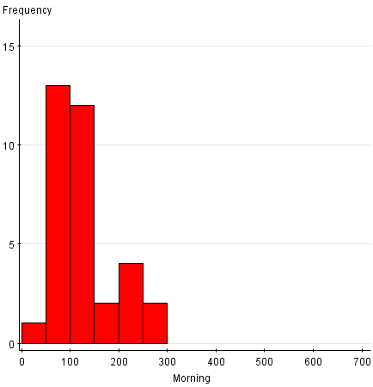
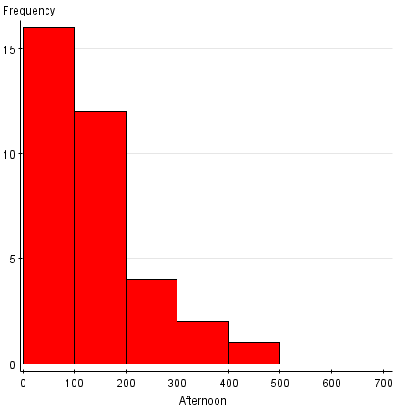
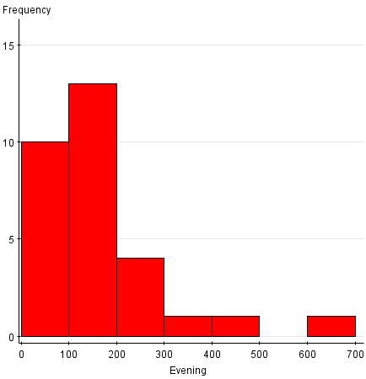
Boxplots
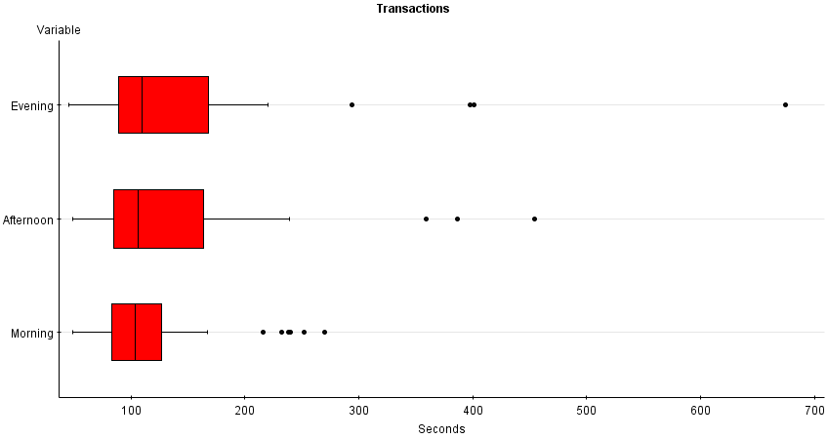

Using Summary Statistics and Graphics
The distributions for the morning transaction times look much different than those for the afternoon and evening hours. The morning has a much smaller range than the other two times as well as less outliers and a much shorter maximum transaction time. Interestingly, the medians for all three time-blocks are very similar which also points to the fact that there are more outliers in the afternoon and evening.

Other Useful Charts
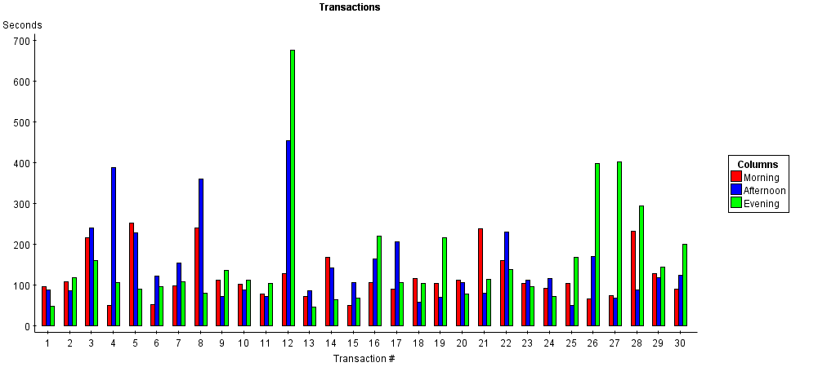

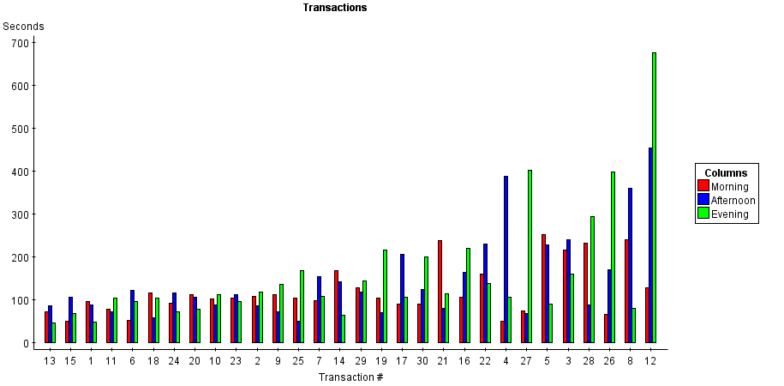

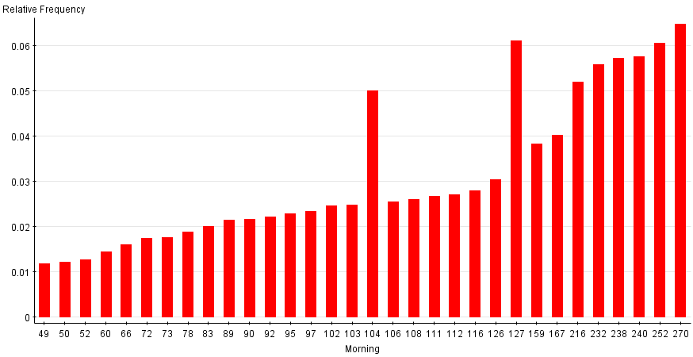

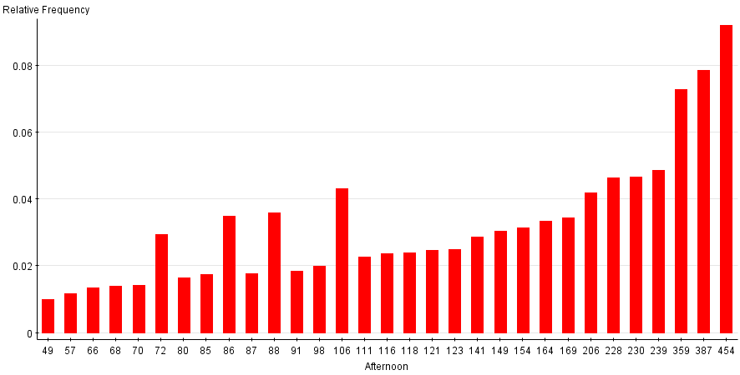
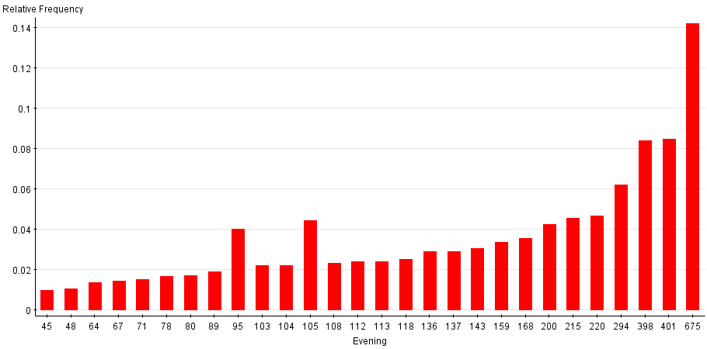
Analysis Plan
As a group we worked to gather quantitative data that would allow us to compare transaction times throughout various time of the day. We then categorized all the various times throughout the day into morning, afternoon and evening. The data seems to indicate that the best time to visit the credit union drive-up windows is between the hours of 9:00 AM and Noon. The morning in general is a great time to visit the credit union based on our analysis and quantitative data. According to the dot plot and the box plot that we were able to put together it was clear that the morning times were more constant and while there were a few outliers none were more than 300 seconds. The evening transaction times were a lot more dispersed and had a major outlier that can greatly influence tests that are not resistant to outliers.
We were able to calculate the mean in seconds it takes to complete a transaction through the drive-up service windows at the credit union. Again our data seems to give us sufficient evidence that using the drive through service in the morning results in quicker service. The mean wait time in the morning was 123 seconds, in the afternoon it was 141, and at night it was 158 seconds. In addition, the standard deviation, standard error, and variance were smaller in the morning times at the branch.
The afternoon and evening graphs all resulted in charts that were skewed right. However, the morning graph was not quite bell shaped but it was close. As we analyze our statistical data we should be able to infer that it is much more predictable and reliable to use the branch drive through service in the morning.
To further analyze the data, we will look at the best statistical test to use based on the basic summary statistics we have produced and discussed above. As we do so, we will ensure we are following the guidelines of the given tests. We will look tests that are not sensitive to outliers and that take into account the skewed nature of some of the data. This will help us gain a better understanding of the information we have gathered. We will also be able to show and explain the data to others so the study is useful to them as they make decisions based on the data.

